Welcome to Fairview Presbyterian Church

Whether you are here for the first time or the 100th time, we are grateful that God has led you to worship with us. We hope you find a place of grace and welcome, where you can be strengthened for the journey ahead. Please feel free to speak with the pastor, usher, or any church member if you would like to learn more about Fairview.

Here are some notes to help you feel at home:
- Restrooms are located through the exit doors closest to the choir loft/piano. Exit through the door to the right of the choir loft and make an immediate right. Continue through the next door and find the restrooms immediately on your left.
- Children are welcome here! Any extra whispers and wiggles remind us that the church is alive and growing. Younger children (age 0-5) are welcome in our staffed nursery. Typically, children ages 3-5 will attend the first part of the service, and head to the nursery after the children’s message. We love for children in first grade and up to stay for the service. Please do what works best for your family, and speak to an usher if you need help finding the right place for your child.
- Communion is typically served the first Sunday of each month. Everyone is welcome to join us in this holy meal (you do not have to be Presbyterian).

Announcements:
- Happy New Year Fairview
- January newsletter in Narthex.
- Please correct any changes on prayer list by submitting new prayer sheet or contact Stacie in church office (770) 963- 7059
email fvsecretary@yahoo.com

Please Pray For Members: Sue Chandler, Penni Detweiler, Pattie Evans, Beth Feustel, Paul Hinton, Becky Perry, Nancy Waldrop,
Izzy Weaver

Friends:
Richard Holmes (relative of Clara Gilbert), Jody Houston (son of Penni Detweiler), Ila Nichols (request of Beth Feustel), Tim Quick (Penni Detweiler’s brother), Mac Hampton and Family (Roger Rushton), Danny Collier (cousin of Clara Gilbert), Caincross Family, Candy and Phillip Curtis (request of the Curtis’s), Nathan Langley (request of Joel Nash), Nehala and her unborn child (request of Clara Gilbert), David Lesneak (family of Sue Beagle), Family of Donna Malone (Sally & Bill Campbell), James Davidson (request of Clara Gilbert), Baby Henry (Jessie Milby’s great grandson)
Extended sympathy to the families of Jeff Gross and Troy Feustel
(Clay Feustel’s brother)

EMERGENCY RESPONSE TEAM:
CONTACT YOUR DEACON OR SALLY CAMPBELL

The Session
Moderator: Rev. Melissa Tidwell
Clerk: Clara Gilbert
Treasurer: Mary Bettinger

Class of 2025 Class of 2026 Class of 2027
Allison Bascas Debi Hancock Donna Redfern
Janet Russell Joice Nash Roger Rushton

The Deacons

Class of 2025 Class of 2026 Class of 2027
Mary Moon Sue Beagle Joe Beagle
Joel Nash Jeff Gross Sally Campbell

The Staff

Pastor, Melissa Tidwell
Lisa Grimsley, Music Director
Nan Gao, Pianist
Stacie Beagle, Office Administrator

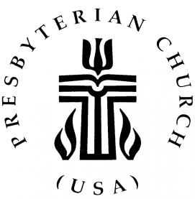

Fairview Presbyterian Church
857 Duluth Hwy • Lawrenceville, GA 30043
(770) 963-7059
fvsecretary@yahoo.com
pastor.fairviewpc@gmail.com
http://www.fairviewpres.org

Worship: 11:00 AM each Sunday
“The heart of Gwinnett since 1823”

Fairview Presbyterian Church
Lawrenceville, GA

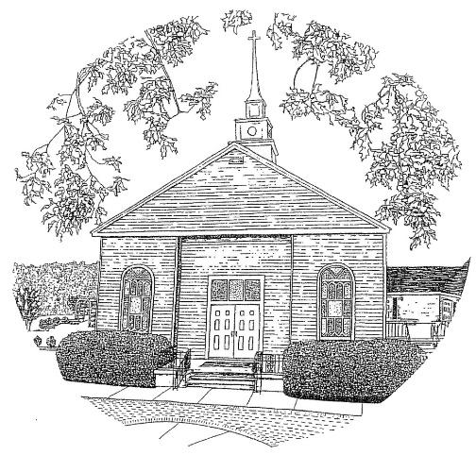

Building on generations of faithfulness, our mission is: to deepen our roots in Christ,
to reach out in love, to grow in God’s grace.

Fairview Presbyterian Church
January 4, 2026 •Epiphany Sunday

We Gather Around the Word
RINGING OF THE BELL

WELCOME
PRELUD “ Joyful. Joyful, We Adore Thee” Beethoven/Classical
*CALL TO WORSHIP Mary Bettinger
Leader: The glory of God has now appeared;
People: through Christ our light, in flesh.
Leader: The reign of God has now arrived;
People: through Christ our king, our eternal ruler.
Leader: The mystery of God has been revealed;
People: through Christ our peace, ever reconciling.
Leader: With the stars to lead us and the magi to teach us,
People: we come, bringing our gifts to worship God. Amen.

OPENING PRAYER Mary Bettinger
O star-flinging God, you lead us ever gently toward your promise. In unlikely ways and through unlikely people, you are always appearing in our midst, bringing greater revelations. Teach us this day to pay attention. Grant us softness of heart, so that we don’t miss your appearance. Bring us into a deeper knowledge of you as we worship and seek you on this feast of Epiphany. Amen.

*HYMN# 288 “We Three Kings” (vs.1-4) American

CALL TO CONFESSION
The light of Christ shines in our lives, even in those corners where sin lurks. Let us seek God’s forgiveness as we pray together.

PRAYER OF CONFESSION
God of love and compassion, you have come into the world and yet we have not recognized you. Forgive our lack of insight and open our eyes to see you here and now, that we may receive your grace through Jesus our Christ. Forgive us for turning from your way, for denying your truth, for resisting the life you would have us live. Refresh us and restore us, that we may see you more clearly and follow more nearly, this day and every day.

ASSURANCE OF PARDON
Grace, mercy, and love—these are the gifts God has given us in Jesus Christ. This is good news! In Jesus Christ we are forgiven!

SUNG RESPONSE (G2G#60) "Praise To God The Father” Ghanaian
Praise to God the Father; praise to God the Son;
Praise to God the Spirit: praise to the Three in One.
Sing praise, sing praise to the Lord on high.
Praise to God Almighty; praise to the Holy One.

We Hear the Word Proclaimed

CHILDREN’S MESSAGE

PRAYER FOR ILLUMINATION Mary Bettinger
Illuminating God, by the power of your Holy Spirit reveal to us through the reading of these words your Word become flesh,
living among us full of grace and truth. Amen.

OLD TESTAMENT Isaiah 60:1-6

ANTHEM “Come, Follow That Star” Traditional

GOSPEL READING Matthew 2:1-12
SERMON “Where the Star Leads” Rev. Tidwell

We Respond to the Word

*HYMN (insert) “At the Turning of the Year” Contemporary
(To the tune of For the Beauty of the Earth)

CALL FOR OFFERING/PRAYER
As the magi entered the house, they knelt in joy and paid homage to Jesus. Opening their treasure chests, they gave gifts to him.
So we come into God’s house today, offering from our own treasure chests gifts to Christ. In that giving, may we see where our star has led us and continue to follow with courage.

OFFERTORY MUSIC

*DOXOLOGY#816 “We give Thee But Thine Own” Traditional
We give Thee but Thine own, whate'er the gift may be.
All that we have is Thine alone, a trust, O Lord, from Thee.

PRAYER OF DEDICATION
Almighty God, by your grace, accept our offerings, not of costly spices or gold but of our lives, our hearts, our work, our dreams. Make us joyful in giving that we may grow in likeness to your supreme gift, Jesus Christ, our Lord. Amen.

SERVICE OF HOLY COMMUNION

INVITATION

GREAT PRAYER OF THANKSGIVING
The Lord be with you.
And also with you.
Lift your hearts.
We lift them to the Lord.
Let us give thanks to the Lord our God.
It is right to give thanks and praise.

WORDS OF INSTITUTION

POST COMMUNION PRAYER
Gracious God, from north and south, east and west, you have gathered us at your table, called us your beloved, and fed us from your grace. Thank you for this foretaste of the heavenly banquet. Let our lives embody your message to the world. With thankful hearts we pray, Amen.

We Carry the Word into the World

*HYMN (insert) “I Am the Light of the World” Contemporary
Tony Grimsley-Guitar

*CHARGE AND BENEDICTION

*CONGREGATIONAL RESPONSE (G2G #702)”Christ be Beside Me”
Christ be beside me; Christ be before me; Gaelic Christ be behind me, King of my heart.
Christ be within me; Christ be below me;
Christ be above me, never to part.

*PASSING OF THE PEACE
Until we meet again, may the peace of our Lord be with you.
And also with you. Amen.

